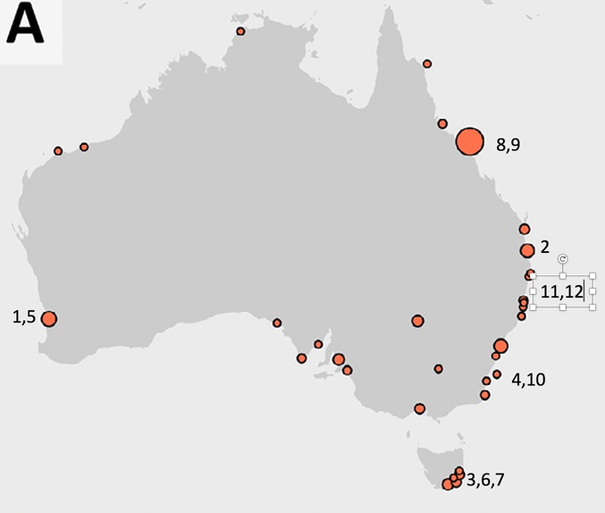

(1) 2020. Swan-Canning River, WA. Jan. Shellfish, crabbing, fishing warning due to *Alexandrium minutum* detection

(2) 2020. Brisbane River, Qld. Sept. *Noctiluca* bloom reported by Julian Uribe-Palomino

(3) 2020. Eagle Hawke Neck, Tas. *Noctiluca* bioluminescence spectacle; 11 July; local news paper report.

(4) 2020. Jervis Bay, NSW. Noctiluca bioluminescence spectacle; 25 July; national news paper report.

(5) 2019. Swan-Canning River, WA. Dec. Shellfish, crabbing, fishing warning due to *Alexandrium minutum + pacificum* detection

(6) 2018. Spring Bay, Tas. Aug-Oct. *Alexandrium catenella* bloom caused up to 5.6 mg/kg PST in mussels

[2017. Adelaide, SA. May. 7 people hospitalised (but recovered) after cleaning tropical coral aquarium, presumed from *Ostreopsis* dinoflagellate aerosols. Hazardous material removal teams called in, country fire service and police cordoned off house. Local media report. DELETED]

(7) 2017. Spring Bay, Tas.: July-Sept. *Alexandrium catenella* bloom caused up to 140 mg/kg PST (200x regulatory level); closure of mussel, oyster, rock, lobster industries, jetties posted with public warning signs.

(8) 2017. Cooktown to Lizard island, Qld; grouper imported in NSW caused 5 human ciguatera poisonings, 2 severe lasting 4 weeks.

(9) 2016. Capel Bank Seamount, Qld; Feb; green job fish imported into NSW caused 5 human ciguatera poisonings.

(10) 2016. Twofold Bay, NSW. October. 8 week bloom by *Alexandrium pacificum*. Shellfish farm closures (up to 7.2 mg/kg PST)

(11) 2016. Crescent Head, NSW. April . 4 ciguatera poisonings from wild-caught Spanish mackerel, tested positive for CTX1

(12) 2016. Crowdy Head NSW. March. 3 ciguatera poisonings from wild-caught Spanish mackerel, tested positive for CTX1.